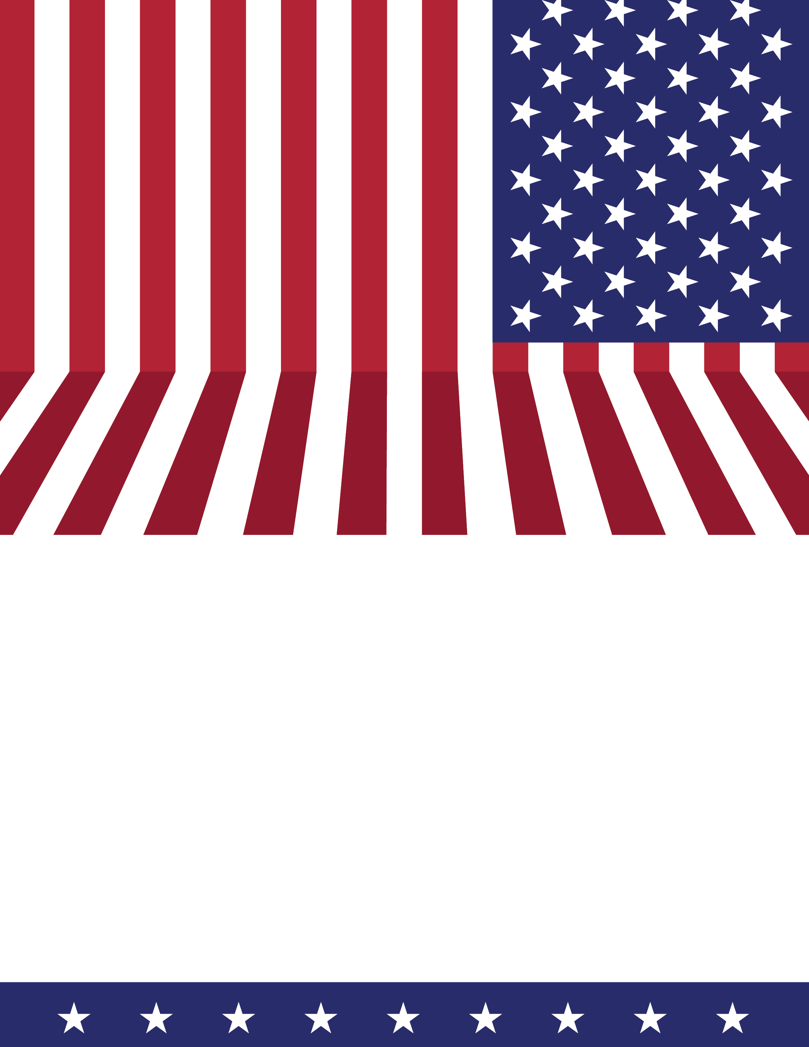
GET EXCITED FOR THE RED, WHITE AND BLUE!

NATIONAL ANTHEM PROUD

A VFW Auxiliary singing contest.
$900 in prizes!

